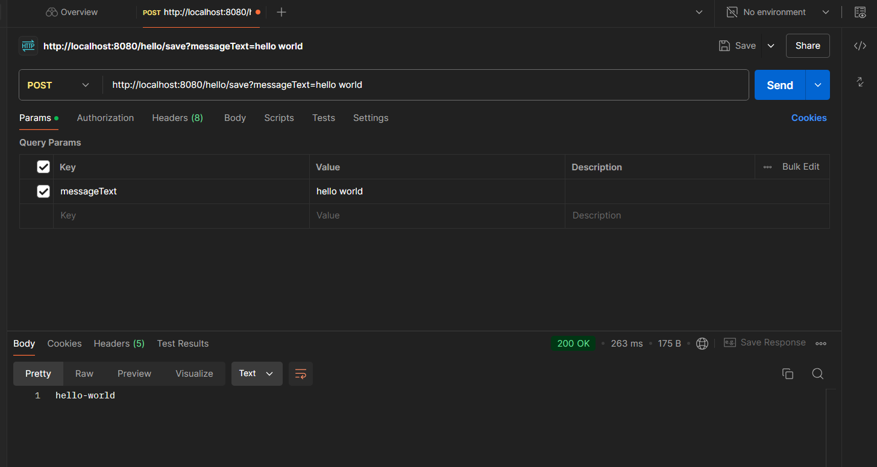

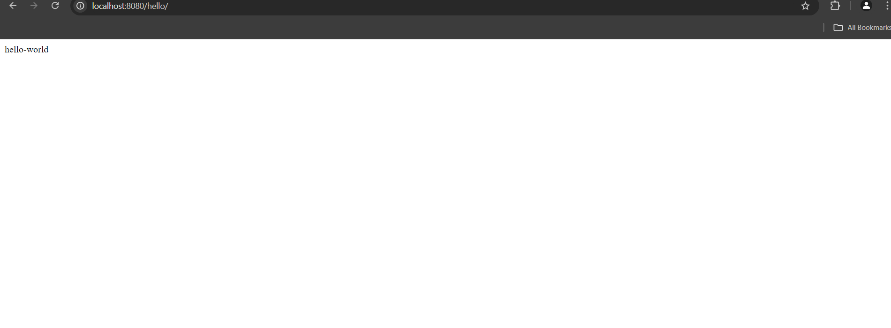

To answer the question

d) Can we build web project without web.xml?

In Spring Boot, you don't need web.xml because it uses embedded Tomcat and auto-configuration

If not using Spring Boot we use Java based configuration with Spring MVC we implement WebApplicationInitializer to configure our DispatcherServlet. The class will act as a replacement for web.xml